//CIS7 - Discrete Structures

//Assignment 18

//Brian Lim

**[1] Give the function g that is part of the formal definition of the directed graph shown**

g(a) = (1,2)

g(b) = (1,3)

g(c) = (2,3)

g(d) = (2,2)

**[2] Use the graph in the figure to answer the qustions that follow.  
a. Is the graph simple?  
b. Is the graph complete?  
c. Is the graph connected?  
d. Can you find two paths from 3 to 6?  
e. Can you find a cycle?  
f. Can you find an arc whose removal will make the graph acyclic?  
g. Can you find an arc whose removal will make the graph not connected?**

a. Yes; there are no oops or parallel arcs

b. No; vert. 1 & 7 have no joining edges

c. Yes; every vertex is reachable from every other vertex

d1. 3, a_3, 4, a_4, 5, a_6, 6

d2. 3, a_5, 5, a_6, 6

e. 3, a_3, 4, a_4, 5, a_5, 3

f. arc a_5

g. arc a_7

[5] Draw K_6

[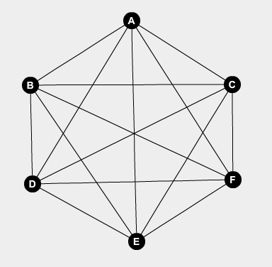](https://camo.githubusercontent.com/1fbac549ef0b185d087836347f811ccf6034633f/68747470733a2f2f692e696d6775722e636f6d2f504b4742716f612e706e67)

**[9]**

**a. The acquaintanceship graph for the IT department and the marketing department of a major corporation is an unconnected graph. What does this imply?  
b. The following figure represents an acquaintanceship graph for residents of an apartment building. Are Carl and Fletcher acquainted? How many people is SiuYin acquainted with?  
c. The length of the shortest path between node a and node b in an acquaintanceship graph is sometimes called the degree of seperation between a and b. What is the degree of separation between Carl and Yuri?**

a. It is implied that no one in the IT department is acquainted with anyone in the marketing department and vice versa

b. Carl and Fletcher are not acquainted, SiuYin is acquainted with Carl

c. Degree of separation is 2

**[13] Which of the following graphs is not isomorphic to the others, and why**

Graph B is not isomorphic to the other because each of the notes in graph B have a degree of at least 1; the others both have a node with a degree of 0

**[30] If all the nodes of a simple, connected, planar graph have degree 4 and the number of arcs is 12, into how many regions does it divide the plane?**

Euler's Formula: n - a + r = 2

let n = number of nodes,  
sum of degrees = 4n.  
To find the number of nodes, use the fact that the sum of degrees is twice the number of arcs a.  
4n = 2(12)  
n = 12 / 2  
n = 6.

Use Euler's Formula to calculate the number of regions:  
6 - 12 + r = 2

-6 + r = 2

r = 2 + 6

r = 8.

The plane is divded into 8 regions.

**[49] Describe the graph whose adjacency matrix is I_n, the n x n identity matrix.**

* Undirected
* N nodes in the graph (n x n identity)
* Loop in the graph at each note
* Graph is unconnected and contains n loops, 1 for each of the n nodes

**[50] Describe the graph whose adjacency matrix is 0_n, the the n x n matrix of all 0’s**

* Undirected
* N nodes in the graph
* There are no arcs in the graph
* Graph is unconnected and contains n nodes, with no arcs connecting any of the notes

**[51] Describe the adjacency matrix for K_n, the simple complete graph with n nodes.**

* Simple Graph, no loops or parallel arcs
* Complete Graph, each nodes is adjacent the other and there is an arc between every pair of nodes
* The adjacency matrix of K_n is an n x n matrix where the entries in the principal diagonal are all 0’s and all other entries are 1’s
* Entries in the ijth place are 0
* Entries in the ijth place, where i=/=/j, is 1

**[65] Draw G’ for the graph of Figure 6.18a**

[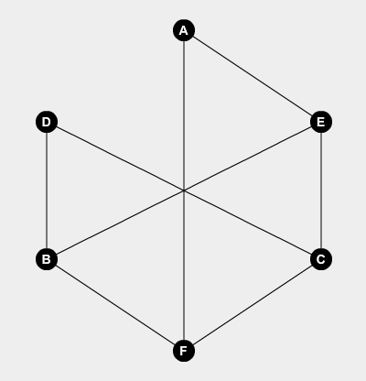](https://camo.githubusercontent.com/41f10ce77874ea2f2329a05f8207a7994941f809/68747470733a2f2f692e696d6775722e636f6d2f555577683171662e706e67)

**[71] Given an adjacency matrix A for a simple graph G, describe the adjacency matrix for G'.**

* Each node is of degree 1 (no loops or parallel arcs in G)
* If there is a 1 in the ijth spot for G and a 0 otherwise, there is a 0 in the ijth spot for G’ and a 1 otherwise
* The adjacency matrix for G’ is an n x n matrix where the ijth place = 0 if the ijth place for G is 1, and the ijth place = 1 if the ijth place for G is 0